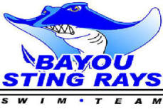
- Red/Blue meet 4:30 warm-ups Monday, May 17th.
- All swimmers 8u on up will swim all 4 strokes
- 6u will swim free and back, with the exception of a few swimming breast and fly, all 6u swimmers are asked to stay at the meet to watch these events.
- We will be working on these strokes again this week. Please be patient, as it takes a long time for our little ones to learn breast and fly and to swim these strokes legally. We will take disqualification slips from weekly meets and work with these swimmers as needed.
- IM’s will only be done in 14 and 18u girls if time permits.
- Swimmers will not be allowed to opt out of IM’s this season. Your team needs you! You will forfeit 1st heat if you opt out.
- Parents are needed for this and all meets. Please give as much time as you can to the team. The best job to watch the races is working as a timer. This is a great place for new parents to start.
- Swimmers and parents please sign in for Saturday’s meet at our pool. Please sign in by Wednesday.

