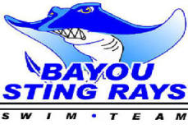
Red/Blue Meet is scheduled for
Monday, May 17th @ 5:00 (Warm-up @ 4:30)

Meet needs:
Goggles Playing Cards
Towels Chairs
Blankets Small toys
Small Games Food/drinks
Suggested foods:
Fruits Vegetables
Sports drinks Pasta
Lunchables (ham/turkey lunchables)
Foods which are not high in fat are appropriate. Avoid chips and soda.

SEE YOU MONDAY @ 4:30 FOR WARMUPS. MEET TO BEGIN AT 5:00.
Parents are needed for the following: timers, stroke judges, card runners. A sign-in sheet will be available in the next day or two.

- Everyone should be using the locker rooms to enter the pool area
for meets and practices. Coaches, board members, and life guards only are allowed in the pool office.
- We will be working more closely with stroke technique in preparation for the Red/Blue meet and our first home meet against ORCA which is schedule for Saturday, May 22nd.
- Parents of younger swimmers please be patient, as it take lots of time and practice to master breaststroke and butterfly. Your child will receive dq slips (disqualification slips) designating the stroke infraction, as well as ribbons for 1st-5th place or for participation.

